My Life, My Illness, and My Assurance in God
By Patricia A. Miller
Book signing at Home Township Library, Monday, December 5 at 6:30am
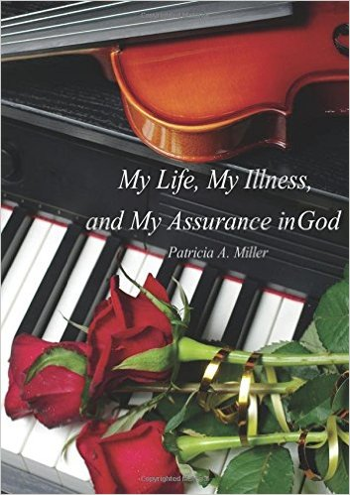
Patricia “Pat” Miller has lived in or near the rural community of Stanton, Michigan most of her life. As a young woman she graduated from the Butterworth School of Nursing in Grand Rapids never dreaming how crucial her medical education would be years later when confronting her life-threatening battle with Guillain-Barre Syndrome. This is her true-life story of courage overcoming challenges to resume an active, meaningful life. This heartfelt, page-turning remembrance speaks of blessings and hardships, as well as the treasured love of her family & friends. But most of all it is the story of her close walk with God who continues to watch over her.
Books available for purchase/signing
Home Township Library, 329 E Main Street, Edmore,
989-427-5241 www.edmore.llcoop.org

